**Blue-Green Deployment**

**What is Blue-Green Deployment?**

* Blue-green deployment is a technique that reduces downtime and risk by running two identical production environments called Blue and Green.
* At any time, only one of the environments is live, with the live environment serving all production traffic. For this example, Blue is currently live and Green is idle. As you prepare a new version of your software, deployment and the final stage of testing takes place in the environment that is not live: in this example, Green.
* Once you have deployed and fully tested the software in Green, you switch the router so all incoming requests now go to Green instead of Blue. Green is now live, and Blue is idle.
* This technique can eliminate downtime due to app deployment. In addition, blue-green deployment reduces risk: if something unexpected happens with your new version on Green, you can immediately roll back to the last version by switching back to Blue.
* Blue/green deployments provide near zero-downtime release and rollback capabilities.
* Blue/green deployment works by shifting traffic between two identical environments that are running different versions of the application.
* Blue environment represents the current application version serving production traffic.
* In parallel, the green environment is staged running a different version of your application.
* After the green environment is ready and tested, production traffic is redirected from blue to green. If any problems are identified, you can roll back by reverting traffic back to the blue environment.

**Weighted Routing:**

* Weighted Routing Policy is used when there are multiple resources for the same functionality and the traffic needs to be split across the resources based on some predefined weights.
* A value that determines the proportion of DNS queries that Route 53 responds to using the current record. Route 53 calculates the sum of the weights for the records that have the same combination of DNS name and type. Route 53 then responds to queries based on the ratio of a resource's weight to the total.
* You can't create non-weighted records that have the same values for **Record name** and **Record type** as weighted records.
* Enter an integer between 0 and 255. To disable routing to a resource, set **Weight** to 0. If you set **Weight** to 0 for all of the records in the group, traffic is routed to all resources with equal probability. This ensures that you don't accidentally disable routing for a group of weighted records.

## 

## 

## 

## 

## 

## 

## 

## **Implementation**

To have identical environments on AWS can be easily achieved by having the same infrastructure configuration or CloudFormation template. As for the “switch”, Route53, AWS DNS management service is sufficient for the job.

Shifting traffic between two environments is essentially switching between DNS endpoints. For example, in the graph below, Blue is live and Green is idle. After Green is ready, Route53 can be switched to Green. Also in the case that Blue fails, it can be switched back to Green.

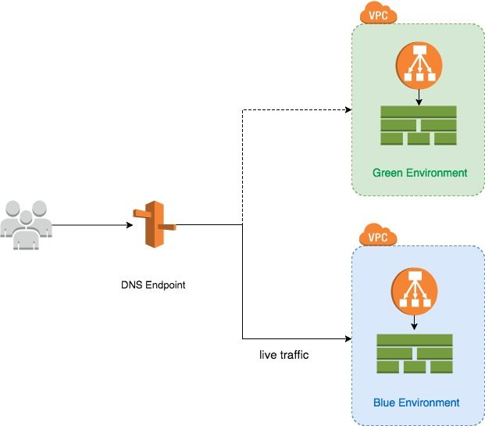

* To get started with implementing weighted routing, log into AWS and then open the Route 53 service.
* Next, click the Get Started Now button found in the Traffic Management section, and click on Hosted Zones, followed by your domain name.
* If you do not currently have a hosted zone in place, then you will need to create one by clicking the Create Hosted Zone button, and then following the prompts to enter your domain name.
* Once you are in the hosted zone, click on the Create Record Set button shown in **Figure 1**.

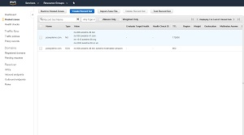

Figure 1

<https://virtualizationreview.com/articles/2020/07/30/~/media/ECG/virtualizationreview/Images/2020/07/Weighted_Routing_1.asxh>

* At this point, a pane will open on the right side of the screen. The upper portion of this pane is used to create a DNS record. You can use the Name field to specify the fully qualified domain name that is to be associated with the DNS record. Just beneath that, you can specify the type of record that you are creating, and you can enter an IPv4 address into the Value field.
* If you look at **Figure 2**, you can see that the Create Record Set pane contains an option to define a routing policy. By default, the routing policy is set to Simple. When you use a simple routing policy, you are essentially just creating a normal DNS record. If your goal is to perform weighted routing, then you will need to change the routing policy to Weighted.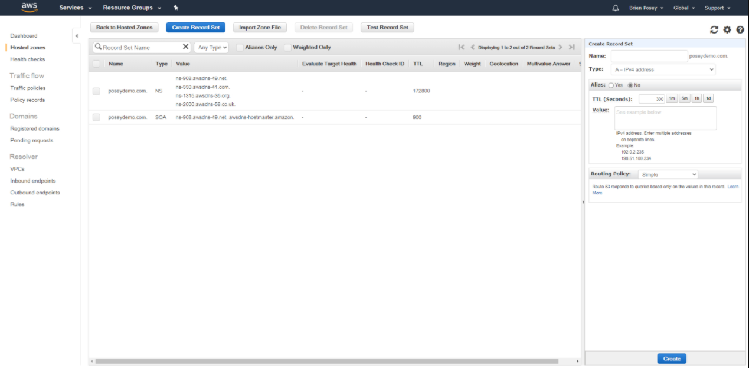

Figure 2

<https://virtualizationreview.com/articles/2020/07/30/~/media/ECG/virtualizationreview/Images/2020/07/Weighted_Routing_2.asxh>

* To create a weighted routing policy, you will need to specify a weight and a set ID. The weight is simply the percentage of traffic that you want to send to the IP address that is associated with the policy.
* Earlier, I mentioned an imaginary situation in which 70 percent of the traffic needed to go to an organization's primary web server and 30 percent needed to go to a secondary web server. If we were to actually implement this architecture, then we would need to enter 0 & 1 in the Weight field for the green and blue server for the traffic to send to the desired IP resp.